 Project Report Template

1. **INTRODUCTION**

**1.1Overview**

**Designing a infographic using canva**

**1.2Purpose**

**We created it for the students to know about ‘FIVE DRUGS THAT ARE RUINING TEENS’.**

1. **Problem Definition &Desing Thinking**

**2.1Empathy Map**

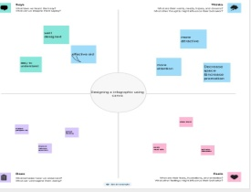

**2.2 Ideation &Brain stroming Map**

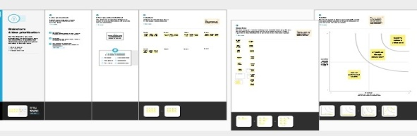

**3.RESULT**

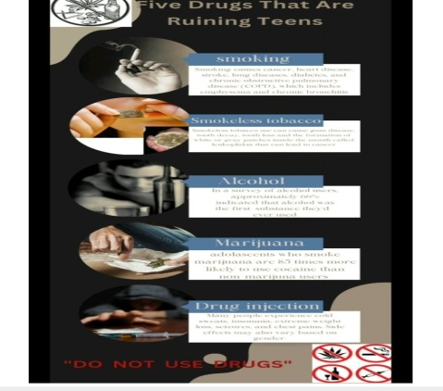

**4.ADVANTAGES &DISADVANTAGES**

**Its is useful for allthe teenage people . awareness about the drugs**.Its disadvantage is,teenage did not have self realization about drugs.wich is reall harmful for people.

5. Application **:**IT is so much useful for the stuents and for their life.

6. CONCLUTION**:**We learn a lot of new things about Editing and make it used for others.